***AIM:***

To design and implement the two bit half adder using Logisim simulator.

***TRUTH TABLE:-***

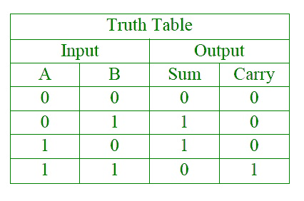

**S = A XOR B C = A AND B .**

***OUTPUT:***

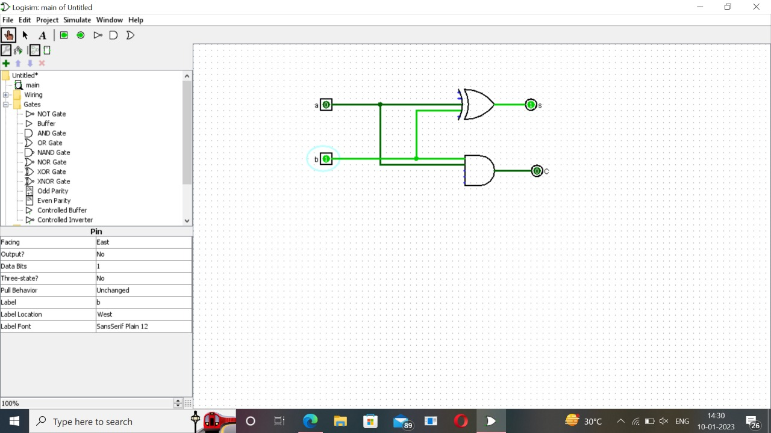

***AIM:***

To design and implement 32-bit full adder by using logisim simulator.

***TRUTH TABLE:-***

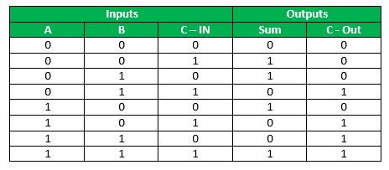

***OUTPUT:***

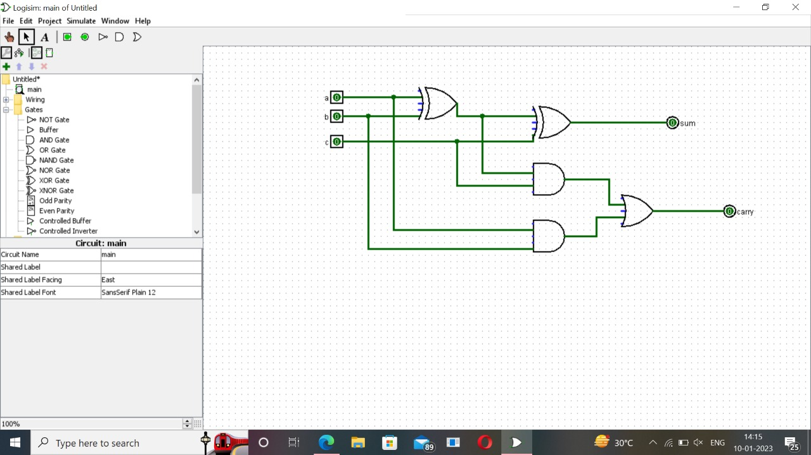

***AIM:***

To design and implement 32-bit full adder with NAND gate by using logisim simulator.

***TRUTH TABLE:-***



***OUTPUT:***

